**Look at the picture**

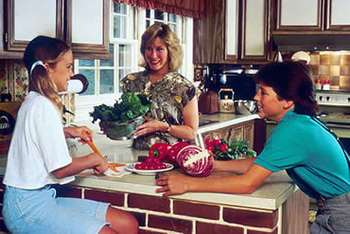

**Choose the right preposition of place:**

1. ____in__the picture, I can see a family ___in____ a kitchen.
2. There is a dish full of fruits _ on______ the worktop.
3. The mother is standing __between_____ her son and daughter.
4. She is holding a vase ___in____ in her hand.
5. The son and the daughter are sitting ____on___ the worktop smiling at each other.
6. There are beautiful cupboards _in front of______ the wall.
7. There is a window ___next to____ the mother.
8. The woman is looking __in front of_____ her daughter.

**Verb to be exercise**

**Complete the following exercises using present the verb to be.**

Peter Baker _______ from Manchester, but Paul and John _______ from London. Manchester and London _______ cities in England. Hamburg _______ a city in Germany. Sandra _______ at school today. Jack and Peter _______ her friends. They

_______ in the same class. Mr and Mrs Baker_______ on a trip to the USA to visit their cousin Anne. She _______ a nice girl. Peter says: "My grandfather _______ in hospital. I _______ at home with my grandmother." What time _______ it? It _______ 8 o'clock.

you tired? No, I _______ not.

**Complete the sentences with the forms of to be in the present simple (am, is, are).**

1. I _______ at home.

2. She _______ not at home in the morning.

3. We _______ in the park.

4. This _______ my new laptop.

5. Our friends _______ on their summer holidays.

6. Uncle George _______ a good football player.

7. The dog _______ under the table.

8. He _______ very funny.

9. The shoes _______ white.

10. You _______ right.

11. Susan _______ good at tennis.

12. They _______ in the house.

13. His T-shirts _______ cool.

14. My sister _______ a good swimmer.

15. She _______ in Italy.